Specialist Mathematics Units 3 & 4
Investigation 2 2017
Vector Applications
Take Home Section
Complete this Take Home Component on file paper showing all working out and reasoning. Use of CAS calculator to aid calculation is assumed, particularly for Questions 2 to 5. On completion of Part 1 there will be a Validation Task (Part 2). For Part 2, CAS calculators will be allowed in the calculator section of the validation, but no other notes will be permitted.
Only the In-class Validation will count towards your score in this investigation.
Part 1: Take Home Component
1. Given two points A<-9,3> and P <3,-3> determine
a) the vector

b) the exact distance between A and P

c) the unit vector

d) the vector equation of the line containing both points

Point C lies on the line AP such that 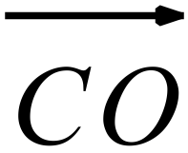 is perpendicular to , 0 being the Origin.
e) Determine the coordinates of point C.

f) Determine .
2. The position vectors (r) and velocity vectors (v) of two ships A and B at 9.00 a.m. on a particular day were as follows:
km km/h.
km km/h.
Show that if the two ships continue with these velocity vectors they will collide.
3. The position vectors (r) and velocity vectors (v) of two ships A and B at 9.00 a.m. on a particular day were as follows:
km km/h.
km km/h.
a) Show that if the two ships continue with these velocity vectors their paths will cross but
they will not collide.

b) Determine the angle between the ships’ respective direction vectors, giving your answer to the nearest degree.

5. Particle P starts moving from a point with position vector < 10, 14 > metres with constant velocity < 5, 2 > metres per second. P continues with this velocity passing a stationary object at A< 34,12 > metres. Determine the closest distance between P and A. State the position of the closest point to A and when this occurs.

5. Objects P and Q start moving from points with position vectors < -5, -15 > m and < 10, 20 > m with constant velocities < 3, -4 > m/s and < 1, -5 > m/s respectively. By using relative positions and relative velocities and a scalar product method, determine the closest distance between P and Q. State the positions of P and Q at the time and when this occurs.

Specialist Mathematics Units 3 & 4
Investigation 2 2017
Vector Applications
Name: ______________________________ Marks: ___ / 6
Validation Section1 Time allowed : 5 minutes
Write your responses in the space provided. CAS calculators will be allowed in Section 2 only but no other notes will be permitted. Other electronic devices must be switched off and in bags.
Many vector procedures in two dimensions can be meaningfully applied in three in exactly the same way, just with a third dimension.
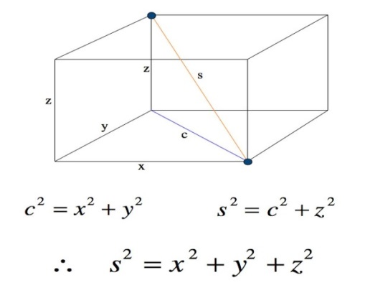
The distance between two points in three dimensions is complicated by the third dimension, and needs to be calculated in the same way you would find the length of the longest diagonal in a box.

1. [ 1, 2, 1, 2 marks = 6 marks]
For the points A = 3i+j, denoted<3,1,0> and P = -i+j+2k, denoted <-1,1,2> , where k is the unit vector parallel to the z axis,
a) Determine the vector

b) the exact distance between A and P

c) the unit vector

The format of the vector equation of a line remains the same in 3 Dimensions.
d) State a vector equation for the line containing both points.

END OF SECTION
Specialist Mathematics Units 3 & 4
Investigation 2 2017
Vector Applications
Name: ______________________________ Marks: ___ / 41
Validation Section 2 Time allowed: 45 minutes
Write your responses in the space provided. CAS calculators allowed in this section only but no other notes will be permitted. Other electronic devices must be switched off and in bags.
Graphic calculator vector operations can be duplicated by converting 2D vector “shapes” to 3D as indicated below.
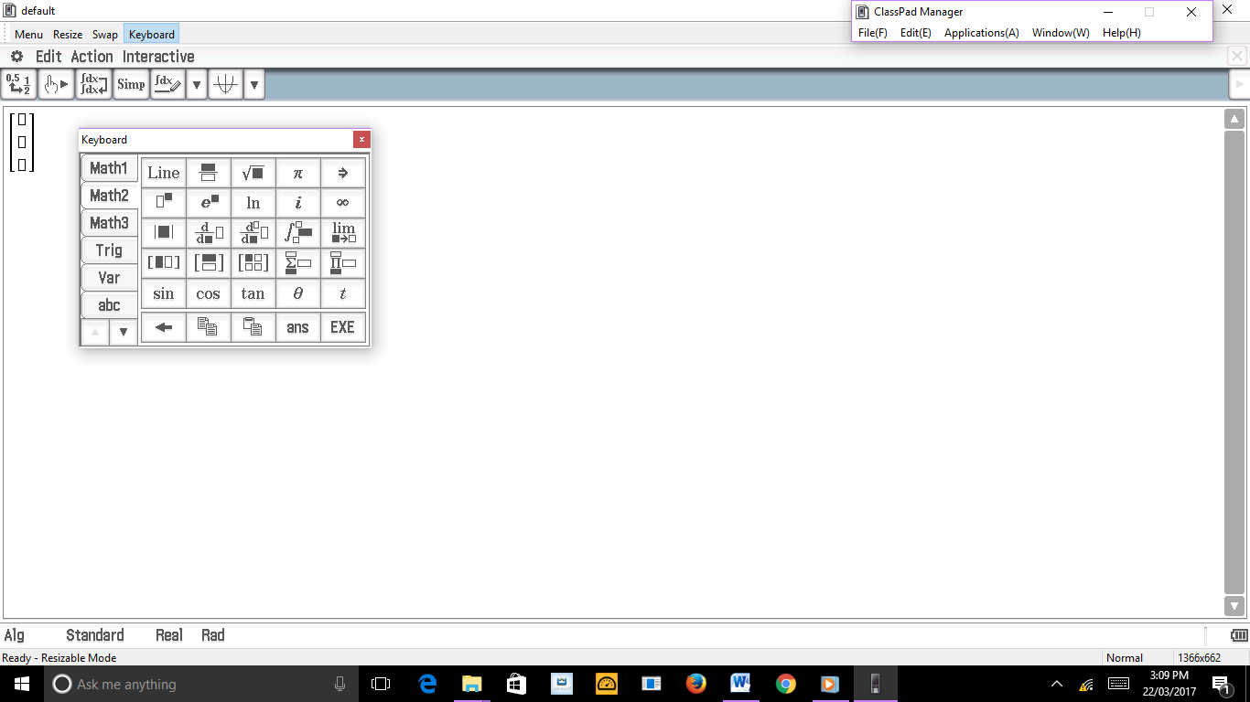
Press this button twice
Otherwise the procedures followed in the Take Home Section can be reproduced using 3D vectors.
2. [ 6 marks ]
Use a scalar product method to determine the distance from point A <2,-3,4> to the point P on the line , where P is the point on that line closest to A.

3. [ 6, 6, 5, 8, 12 = 37 marks ]
During army war games a targeted drone T is being shot at using a non-guided missile A. The position vectors are in multiples of 100m at the time t = 0 and the velocities in 100m/s.
R_{T} = v_{T} = r_{A} = v_{A} =
a) [ 6 marks ]
Assuming both maintain the same velocities show that the target will be hit by the missile. State the position coordinates and the time of that collision.

b) [ 6 marks ]
Missile B is also fired at the drone. Its position and velocity vectors are given below.
R_{B} = v_{B} =
Show that the missiles’ paths will cross but that they will not collide. Give the coordinates of the point of their crossing and the time difference between their passing.

c) [ 5 marks ]
Determine the angle between the missiles’ direction vectors, to the nearest degree. Full working must be shown for full marks.

Missile B’s path takes it past an observation platform, situated at <42,79,2>.
d) [ 8 marks ]
How close does the missile get to the platform to the nearest 100m ?

e) [ 10 marks ]
We have already established that Missiles A and B smoke trails crossed.
Assuming both were fired at exactly the same time, determine how far apart they were at their closest point to the nearest 100m and when they came closest to each other to the nearest tenth of a second ?

END OF PAPER

